1. Adding Process Priority

Step 1: Add priority to struct proc in proc.h

Step 2: Assign default priority in allocproc() in proc.c

Step 3: Modify cps() in proc.c

Follow steps from previous report

Step 4: create program foo.c

Step 5: add function chpr()

Step 6:Add sys_chpr() in sysproc.c

Step 7:add chpr as system call steps in previous report

Step 8: create a file nice.c with which chpr called and priority of process is changed

Step 9: add nice and foo in the makefile

Step 10: to test create process using foo and then change priority using nice

Output is attached below.

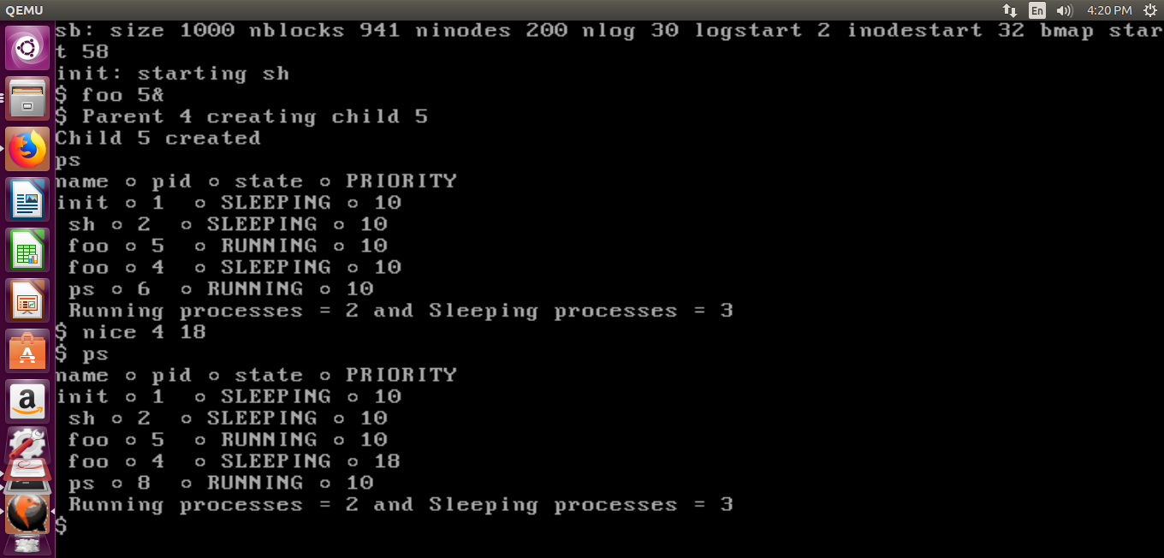

1. XV6 Process Priority Scheduling

Step 1: Give high priority to a newly loaded process by adding a priority statement in exec.c

Step 2: Modify foo.c so that the parent waits for the children and adjust the loop for your convenience

Step 3: Observe the default round-robin (RR) scheduling.

RUN foo &; foo &; foo &

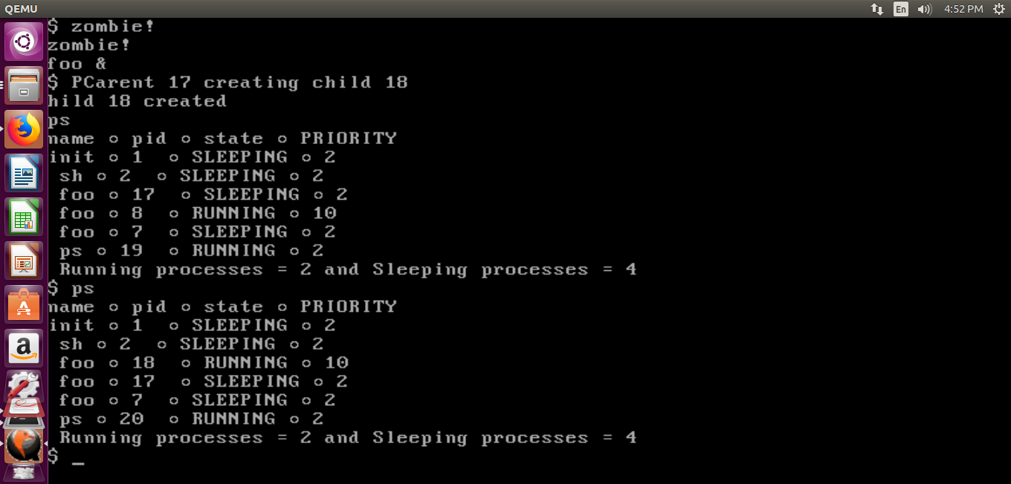

Step 4: Implement Priority Scheduling. (modify scheduler in proc.c)

Step 5:Run foo &; foo &; foo & and observe the priority scheduling.

